
Department of Cancer Epidemiology and Prevention Research
REACH Centre, 2nd Floor
Alberta Health Services – Cancer Care Alberta
Phone: (403) 476-2746
E-mail: AYAPACT@ahs.ca

Dear AYA-PACT Study Participant,

Thank you for your participation in the study. At this time, you will receive one activity monitor that we would like you to wear on your midsection for seven consecutive days and nights. The purpose of the activity monitor is to collect information about your usual day-to-day activity along with sleeping patterns.

Please begin wearing the monitor on ________________(am) when you get up in the morning and wear it for seven days and nights until you wake up on the morning of _______________(am).

Note:
THE Device IS only set to record ON the daTEs indicated above. If you receive the DEVICE early, please DO NOt start wearing IT Until THE start date indicated above. if you receive IT after the start date, PLEASE contact study staff at (403)476-2655.

Please return the monitor and the completed Activity Monitor Daily Log to study staff when you come for testing at the REACH Centre.
Appointment Date and Time: _____________________________

Please see next page

INSTRUCTIONS:

ActiGraph GT3X Plus

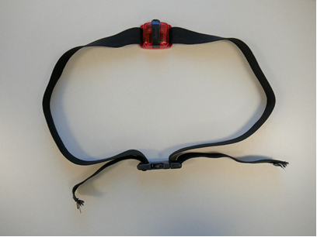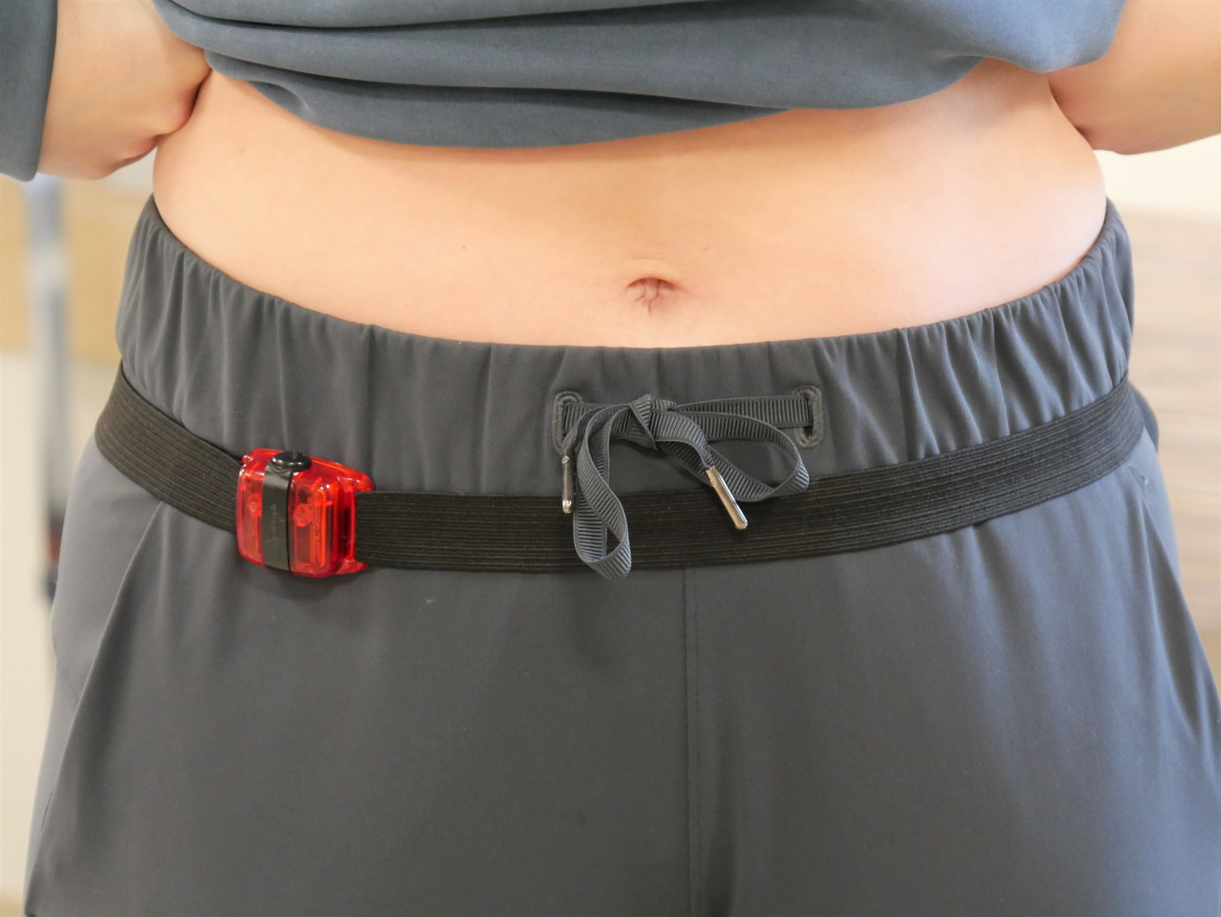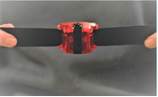
Elastic Belt
Snap Buckle
ActiGraph
Button

- Attach the monitor to your midsection with the elastic strap using the snap buckle on the strap to fasten the monitor to your midsection. Wear the activity monitor so that the back of the red box (screws showing) is against your right side in line with the armpit and knee with the button facing up.

- The belt and activity monitor should be worn as close to your body as possible - skin contact underneath your clothing is best. This position will allow the monitor to take the best measurements.

- The activity monitor should be snug against your midsection when worn. Make sure that the monitor is not uncomfortably tight or too loose.

General Notes:

- Wear the monitor from the time you get out of bed in the morning on the first day until the morning of the eighth day as listed on the front page.

- The activity monitor is NOT waterproof. Please do not wear the device while bathing, swimming or other water-based activities, but do remember to put the device back on afterwards.

- These monitors are very expensive, so please take extra care with them.

- Record all activities that you participate in when you have to remove the activity monitor in your Activity Monitor Daily Log.

If you have any questions,
please contact the AYA-PACT Study Coordinator at:
(403) 476 - 2746 or AYAPACT@ahs.ca

